# **Great North Assignment**

## **By Ivan Heaslip - 24/07/24**

### **Importing ZIP**

Import zip file > Drag > Open.

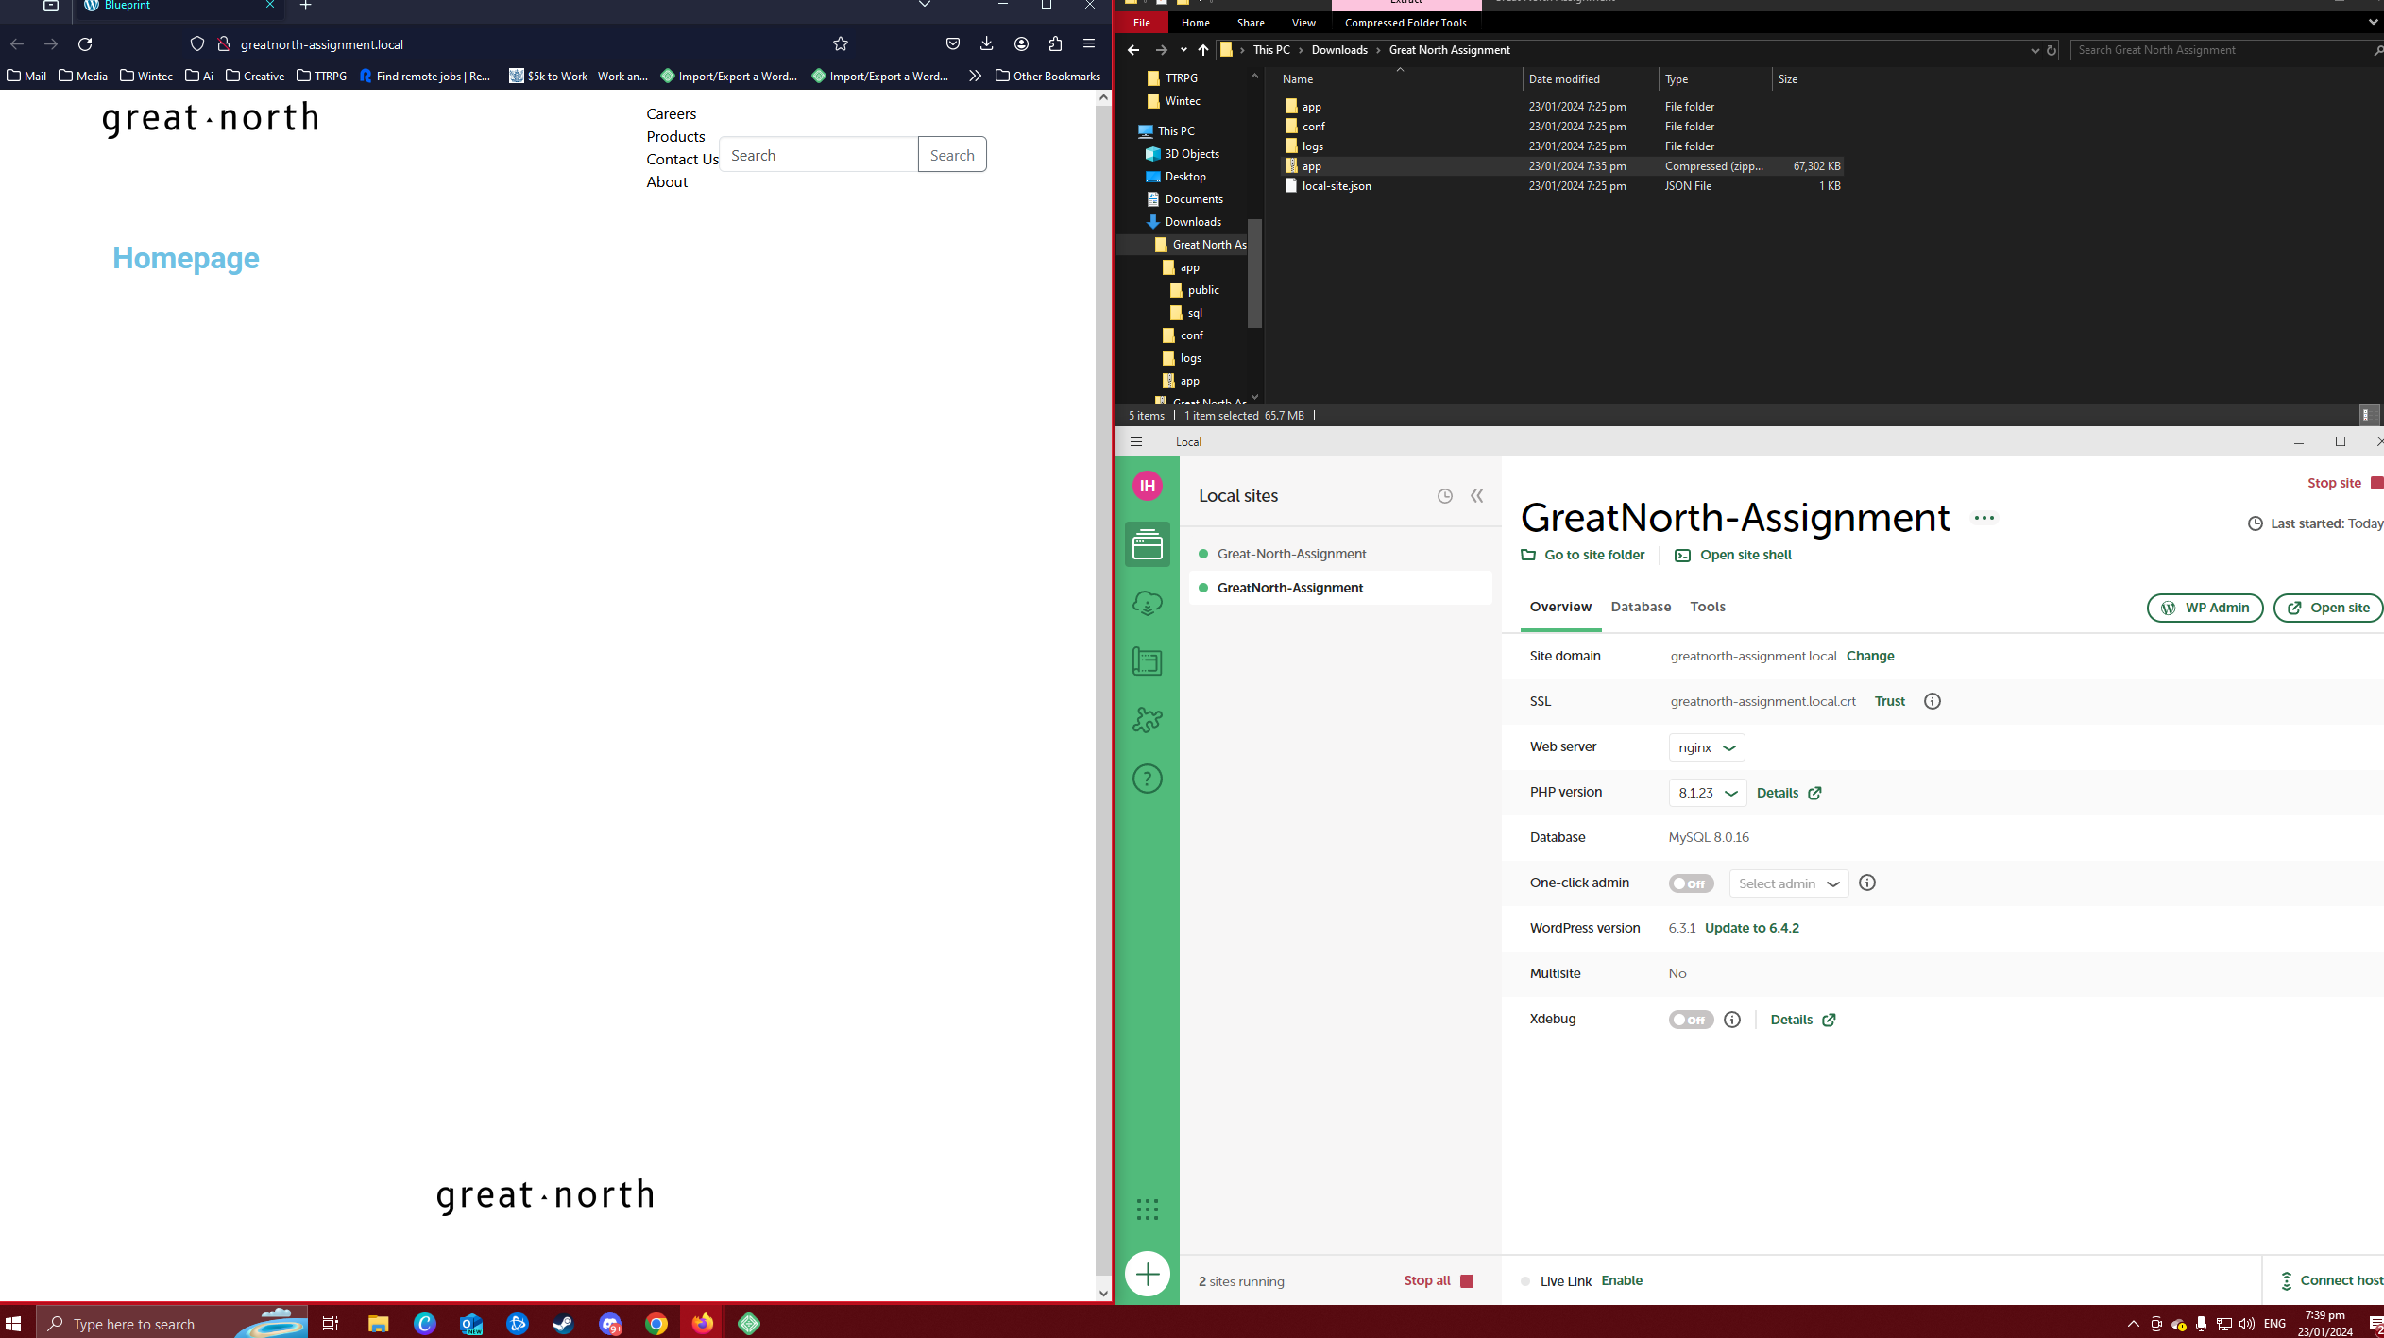

### **The header is stacked vertically, we would like it horizontal.**

* Visit website > Edit Page > + symbol, Toggle block editor > Insert Navigation.

### **The mobile header is not animating in when someone clicks the hamburger button, can you fix that?**

* Unsure on how to fix this, I tried troubleshooting, but it appears that functionality is there just no animation.

### **We want a different logo in the footer, can you make it so we can add our own easily?**

* Added image widget, just select image you wish to upload. Appearance > Widget > Third widget area.

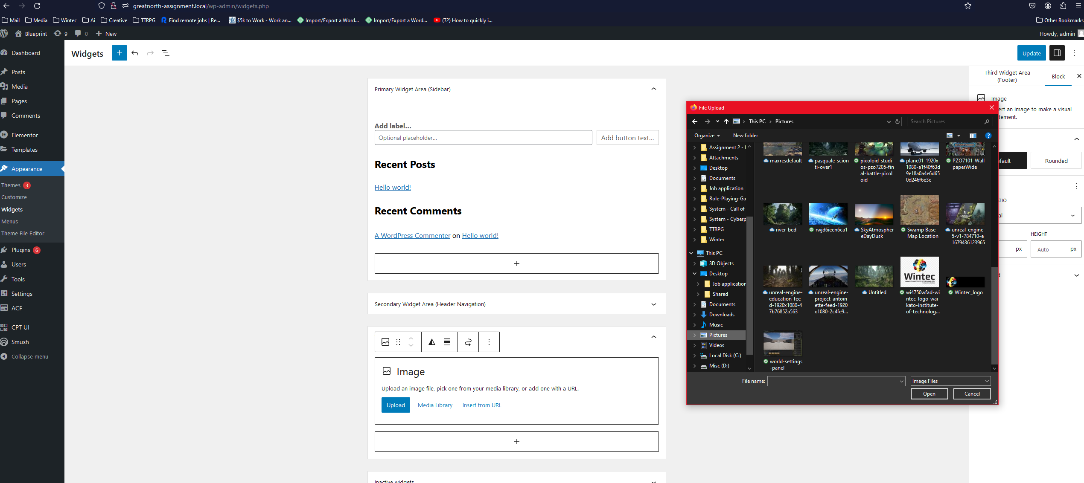

### **I tried making a change to the product page and it stopped loading? It should display a product name, a product description, and the price.**

* Page will load, but I think the details are related to a plugin being outdated, but due to updating plugins being outside the scope I wont attempt to do that.

### **We have a custom Elementor widget that just went missing on the homepage, can you restore it? (This is a tough one, we don’t expect you to get this one).**

* Within my attempt to figure out widgets I was playing around with the edit menu, it appears this one was disabled.

* Edit page > Homepage > Select add block > Working?

## **breakdown**

1. **Header Alignment:**
   * **Approach:** I reviewed the CSS styles responsible for the header layout, but it appears modifying through WordPress wouldn’t work. To change it from a vertical to a horizontal arrangement, I added a new menu property and adjusted the styling accordingly.
   * **Solution:** Edited the webpage styles to set the header items to display horizontally.
2. **Mobile Header Animation:**
   * **Approach:** Checked the theme code associated with the hamburger button and mobile menu animation. Unsure on how to implement this.
   * **Solution:** Unsure, will investigate fixing this. Functionality is working just not to standard.
3. **Customizable Footer Logo:**
   * **Approach:** Examined the footer code and identified the section responsible for the logo. Implemented a dynamic way to replace the logo easily by adding a widget that the admin could upload an image to.
   * **Solution:** Introduced a customizable Widget where users can upload or link to their preferred logo for the footer.
4. **Product Page Loading Issue:**
   * **Approach:** Inspected the recent changes made to the product page and checked for any errors in the code or dashboard menu. Unknown why it wouldn’t produce the function. I believe it’s a plugin that needs updating.
   * **Solution:** Unsure, plugin may need updating but page is loading now.
5. **Restoring Missing Elementor Widget:**
   * **Approach:** Investigated the homepage Elementor setup to identify any issues with the missing widget. Checked the Elementor edit page if available to find when the widget disappeared. Found it within the edit page and enabled it.
   * **Solution:** Restored the missing Elementor widget by either reverting to a previous working version, manually adding the widget back to its original location on the homepage.